Newtuple Design Language Guideline (Unified System for All Collateral)

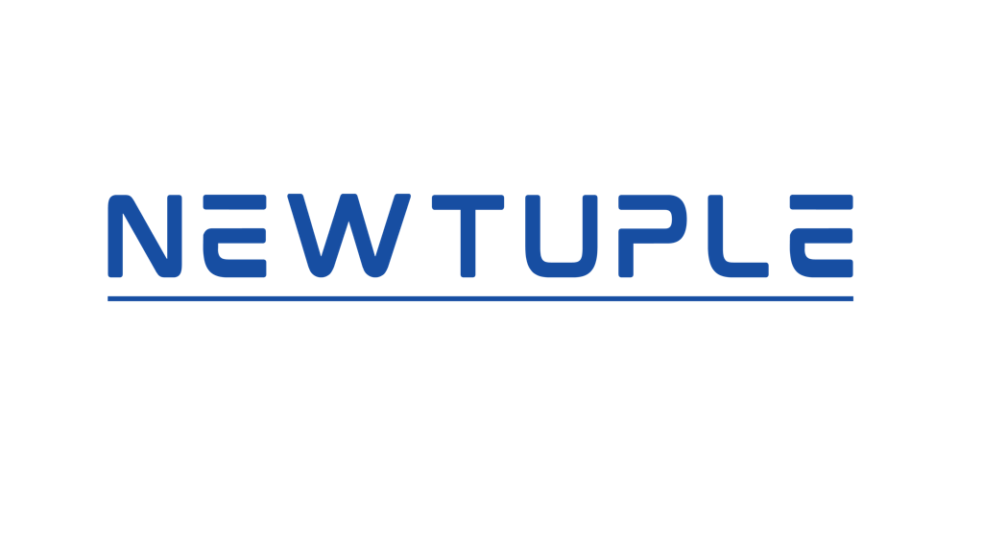

1. Introduction
Purpose: This document defines Newtuple’s unified design language — a living, system-driven guide ensuring visual and experiential consistency across all touchpoints: website, dashboards, presentations, booths, videos, and marketing material.
Scope: Applicable to all brand expressions - digital (web, UI, dashboards, slides, social) and physical (print, booth design, environmental graphics).
Core Principles:
- Minimalism – Remove the unnecessary; design for clarity and focus.
- Clarity – Prioritize readable hierarchy and clean information flow.
- Sophistication – Express technical mastery through visual restraint.
- Reliability – Build trust through consistent patterns and tone.
- Human + Technical Balance – Combine empathy with precision.
- Cobalt Signature – The cobalt blue logo color (#0047AB) anchors every visual system.

2. Brand Identity Overview
Brand Essence: Building the agentic enterprise future where humans pilot and AI agents execute.
Brand Personality: Professional, intelligent, reliable, technically sophisticated, and warmly human.
Voice & Tone:
- Visual Voice: Minimal, open, and precise: less decoration, more purpose.
- Copy Tone: Confident yet conversational; authoritative, never arrogant.
- Interaction Style: Predictable, smooth, and intentional.
Mission Tagline: Build Your Agentic Enterprise.
Design Philosophy: Each design decision reflects calm precision. Motion and contrast guide attention rather than demand it.
3. Logo Guidelines
Primary Logo: The official Newtuple logo in Cobalt Blue (#0047AB) as shown above. This is the master mark: it must not be altered, recolored, or distorted.
Usage Rules:
- Maintain clear space equal to the height of the “N” on all sides.
- Logo should appear on white or neutral backgrounds only.
- Never apply effects, gradients, or shadows.
Variants:
- Primary: Blue on white (default for all digital and print media).
- Inverse: White on blue (use for dark or Cobalt backgrounds).
- Monogram: The “N” can be used alone for icons or favicons.
Minimum Sizes:
- Digital: 32px height.
- Print: 10mm height.
4. Color Palette
Primary Palette:
- Cobalt Blue: #0047AB — Signature brand color, symbolizing intelligence and trust.
- White: #FFFFFF — Primary background and whitespace.
- Black: #000000 — Strong accents and typography.
- Gray 900 / 600 / 50: Supporting neutrals for depth and accessibility.
Accent Gradient:
- from-[#0047AB] to-[#00B8D9] — Used only for hero text or select motion backgrounds.
Functional Colors:
- Green 500 — Success states.
- Yellow 500 — Highlights or integration indicators.
- Red / Amber — Warnings or lifecycle transitions.
Usage Notes:
- Cobalt Blue is used sparingly and purposefully — never decorative.
- White is dominant; it embodies space and clarity.
- Gradients are rare, used only for emphasis.

5. Typography & Fonts
Primary Font: System font stack for scalability and neutrality.
Font Weights:
- ExtraLight – Hero and key statements.
- Light – Body and descriptions.
- Medium – Buttons, labels.
- SemiBold – Section headers.
- Bold – Numeric data or emphasis.
Hierarchy:
- H1: Large, extra-light, tracking-tight.
- H2: Light, wide-spaced section headers.
- H3: Compact, elegant, light.
- Body: Relaxed line height, gray-600.
- Labels: Uppercase, small, tracking-wider.
Cross-Medium Guidance:
- Web/UI: Responsive sizing with rem units.
- Slides: Larger type ratios for distant readability.
- Print: Adjust contrast, slightly tighter spacing.

Use case | Font | Weight | Example Size
H1 – Hero | Inter ExtraLight (200) | 64–72 pt
H2 – Section Header | Inter Light (300) | 40–48 pt
H3 – Subsection | Inter Regular (400) | 28–36 pt
Body Large | Inter Light (300) | 20–22 pt
Body Regular | Inter Light (300) | 18–20 pt
Labels / Buttons | Inter Medium (500) | 12–16 pt
Data / Metrics | Inter Semibold (600) | Variable (28–48 pt)

6. Imagery & Illustration
Style: Abstract and geometric; avoid photography unless storytelling demands it.
Icons:
- Lucide React icons (outline only).
- Stroke: 1px, color inherits or Cobalt Blue.
Illustrations:
- Simple, flat geometry. Symbolize flow, connection, and intelligence.
Do’s:
- Use monochrome imagery with selective Cobalt highlights.
- Use icons to clarify, not decorate.
Don’ts:
- Mix icon styles or colors.
- Use literal photography for technical products.

7. Layout & Composition
Grid: 12-column grid for web; modular for slides and print.
Spacing: Generous vertical rhythm (py-20–py-32), consistent internal spacing (p-8–p-12).
Whitespace Philosophy: White is as important as content; it allows sophistication and clarity to breathe.
Alignment:
- Text: Left-aligned for readability.
- Hero/Key visuals: Centered or balanced asymmetry.
- Booths: Centered for impact, grid-aligned signage.
Corners & Radius: Rounded-3xl for cards, rounded-full for buttons.

8. Motion & Interaction
Principle: Motion = clarity. Always purposeful, never decorative.
Durations: 300ms for hover, 500ms for transitions, 6s for background float.
Easing: ease-in-out.
Applications:
- Hover → subtle scale or color accent.
- Fade-ins → gentle, one-directional.
- Scroll effects → progressive, not parallax.
Cross-Medium Consistency: Motion tempo should remain consistent between website, videos, and on-screen loops at exhibitions.

9. Component Patterns
Primary CTA: Cobalt Blue background, white text, rounded-full.
Secondary CTA: White background, blue text with blue border.
Cards: Light gray background, border-gray-200, hover border-blue.
Sections: Max width 7xl, centered content, large breathing space.
Navigation: Fixed top, translucent white with subtle blur.
Footer: Cobalt Blue background, white text, clean grid layout.
Slide & Booth Parallels:
- CTA → Key message card.
- Card → Content panel.
- Navigation → Slide header strip.
- Footer → Closing statement / contact band.

10. Accessibility & Responsiveness
- Minimum contrast ratio AA.
- Font size scales across screen types.
- Interactive elements include hover/focus states.
- Large text and high contrast in physical signage.
11. Verbal & Copy Guidelines
Voice: Calm authority. Speak like a practitioner, not a vendor.
Tone per Medium:
- Web: Direct, informative.
- Slides: Narrative, crisp, confident.
- UI: Clear and minimal.
- Booth/Print: Impactful, declarative.
Language Mechanics:
- Use active voice.
- Avoid buzzwords; use precise technical vocabulary.
- Always align copy with design tone: clarity > flair.

12. Signature Visual Elements
- Cobalt Gradient Text: from #0047AB → #00B8D9 for emphasis.
- Floating Circles: Cobalt/gray with slow movement.
- Chevron Connector: Represents process flow and transformation.
- Backdrop Blur: Metaphor for human clarity emerging from AI complexity.

13. Brand Expression Across Mediums
Medium | Primary Colors | Layout Behavior | Motion/Interaction | Example Use
Website/UI | White + Cobalt | 12-column responsive | Subtle fade/hover | Product page, case study grid
Slide Decks | White base, Cobalt headers | 16:9 modular grid | Appear by line | Case study storytelling
Print Collateral | Matte white, Cobalt ink | Symmetric margins | None | Brochures, one-pagers
Booth/Exhibition | Cobalt background, white text | Center-aligned | Ambient fade motion | LED wall, signage
Dashboards | Neutral gray base, Cobalt highlights | Card-based grid | Smooth transitions | Internal analytics UI
14. Summary
The Newtuple Design Language unites brand, product, and environment into a single, scalable identity system. It reflects the intelligence and precision of a company shaping the agentic enterprise era — calm, consistent, and confidently blue.
The Cobalt Blue from the logo is a symbol of clarity, trust, and technology in harmony with human design.

